syllabus
International Migration
University year 2025/2026

1. Information regarding the programme
1.1. Higher education institution | Babeș-Bolyai University
1.2. Faculty | Faculty of Sociology and Social Work
1.3. Department | Sociology
1.4. Field of study | Sociology
1.5. Study cycle | BA
1.6. Study programme/Qualification | Sociology

1.7. Form of education

2. Information regarding the discipline
2.1. Name of the discipline |  |  | Internațional Migration |  |  |  |  |  | Discipline code | ALR3420
2.2. Course coordinator |  |  |  |  |  | Manuel Mireanu PhD
2.3. Seminar coordinator
2.4. Year of study |  | 2.5. Semester |  |  | 2.6. Type of evaluation |  | E | 2.7. Discipline regime |  | Elective course

3. Total estimated time (hours/semester of didactic activities)
3.1. Hours per week |  | 2 | of which: 3.2 course | 2 | 3.3 seminar/laboratory
3.4. Total hours in the curriculum |  | 28 | of which: 3.5 course | 28 | 3.6 seminar/laborator
Time allotment for individual study (ID) and self-study activities (SA) |  |  |  |  |  | hours
Learning using manual, course support, bibliography, course notes (SA) |  |  |  |  |  | 26
Additional documentation (in libraries, on electronic platforms, field documentation) |  |  |  |  |  | 10
Preparation for seminars/labs, homework, papers, portfolios and essays (mai mare sau egal cu nr. total ore prevăzut în calendarul disciplinei pentru temele de control) |  |  |  |  |  | 0
Tutorship |  |  |  |  |  | 2
Evaluations |  |  |  |  |  | 2
Other activities: [de ex.: comunicare bidirecțională cu titularul de disciplină / tutorele] |  |  |  |  |  | 2
3.7. Total individual study hours | 42
3.8. Total hours per semester | 70
3.9. Number of ECTS credits | 3

4. Prerequisites (if necessary)
4.1. curriculum | -
4.2. competencies | -

5. Conditions (if necessary)
5.1. for the course | -
5.2. for the seminar /lab activities | -

6. Specific competencies acquired
Professional/essential  competencies | Designing and conducting sociological research (collection, processing, and analysis of social data) in organizations and communities, cultural research, market studies, etc.  Diagnosis of the organizational environment  Appropriate use of the applied sociological perspective
Transversal competencies | Applying strategies of rigorous, efficient work, punctuality, and personal responsibility for results, based on the principles, norms, and values of the professional code of ethics.  Applying group interaction techniques, empathetic interpersonal communication skills, and assuming specific roles within teamwork.  Efficient use of informational sources and resources for communication and assisted professional training (Internet portals, specialized software applications, databases, online courses, etc.), both in Romanian and in an international language.  Using an international language for studying bibliographies, writing scientific texts, and presenting results to an international audience.
7. Objectives of the discipline (outcome of the acquired competencies)
7.1 General objective of the discipline | This class provides a critical perspective on various concepts and phenomena situated at the intersection between international relations, political science and sociology. We will discuss issues in which global dynamics are reflected in everyday life, by looking especially at moments of change and conflict. The main focus will be on the ways in which some individuals and groups who flee (from war zones, climate catastrophes or economically marginalized areas), seeking refuge and asylum in Europe, are constructed as threats to state security. We will discuss the historical relationship between the state, violence and territory - and the ways in which this relationship translates today into security practices directed against people coming from areas deemed to be problematic.
7.2 Specific objective of the discipline

8. Content
8.1 Course | Teaching methods | Remarks
1. Introduction
2. History of the nation state in relation to violence and territory
3. Security and protection of the population as raison d'état
4. The border as a site of state violence
5. State as empire and colonial territoriality
6. The European Union as empire and the control of its borders
7. War and peace on EU borders
8. Asylum policies in the EU and Romania
9. Detention and solitary confinement, areas of suspension of rights
10. Repression, securitization and criminalization of refugees
11. Society's participation in repression
12 Repressive practices of the far right
13 Acts and practices of resistance against the violence of securitization
14 Conclusion and feedback session
Bibliography
8.2 Seminar / laboratory | Teaching methods | Remarks
Bibliography

9. Corroborating the content of the discipline with the expectations of the epistemic community, professional associations and representative employers within the field of the program

10. Evaluation
Activity type | 10.1 Evaluation criteria | 10.2 Evaluation methods | 10.3 Percentage of final grade
10.4 Course
10.5 Seminar/laboratory
10.6 Minimum standard of performance

11. Labels ODD (Sustainable Development Goals)
 | General label for Sustainable Development
 |  |  | 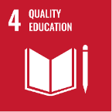 | 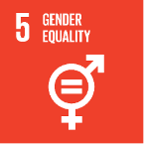 | 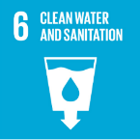 |  |  | 
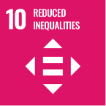 | 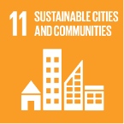 | 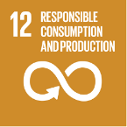 |  | 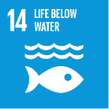 | 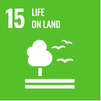 |  | 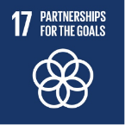

Date:  ... | Signature of course coordinator  ..................... |  | Signature of seminar coordinator  .....................
Date of approval:  ... |  | Signature of the head of department  .....................

One can choose either competences or learning outcomes, or both. If only one option is chosen, the row related to the other option will be deleted, and the kept one will be numbered 6.
Keep only the labels that, according to the Procedure for applying ODD labels in the academic process, suit the discipline and delete the others, including the general one for Sustainable Development – if not applicable. If no label describes the discipline, delete them all and write „Not applicable.”.

